
Security Operations Centre (SOC) Practical Lab and Monitoring Report

THEORETICAL PART -
1. SOC fundamentals and operations.
1.INTRODUCTION
SOC Fundamentals and Operations- A Security Operations Centre(SOC) is a centralized unit that monitors, detects, analyze, and responds to cyber security incidents in an organization. The main purpose of a SOC is to ensure continuous security monitoring, protect systems from cyber threats, and respond quickly to security incidents.
In this project, a mini SOC lab was implemented using virtual machines and open-source security tools such as Kali Linux, Windows VM, Wazuh, Wire shark, and Osquery. The objective of this lab is to understand SOC operations, security monitoring, log analysis, and incident response through practical implementation.

2. Objective of the Project

The objectives of this SOC lab are:
- To understand the working of a Security Operations Centre.
- To learn how security threats are detected and analyzed.
- To practice log monitoring and traffic analysis.
- To implement security tools for detection and response.
- To document and analyze security incidents.

3. Purpose of SOC
The main purpose of a SOC is: Proactive threat detection, Incident response ,Continuous system monitoring, Risk reduction, Protection of organizational assets
. SOC helps organizations identify attacks at an early stage and minimize damage.

Roles in a SOC
A SOC consists of different roles:
Role | Responsibility
Tier 1 | Monitors alerts and performs initial analysis
Tier 2 | Investigates confirmed threats
Tier 3 | Handles advanced threats and malware analysis
SOC Manager | Manages SOC operations
Threat Hunter | Proactively searches for hidden threats

4.Key Functions of SOC- Log Analysis ,Alert Monitoring ,Incident Handling ,Threat Intelligence ,Vulnerability Management ,Reporting and Documentation

2. Security Monitoring basics-

2.1 Objectives-

Security Monitoring is the process of continuously observing system activities, network traffic, and security logs to detect suspicious behavior, unauthorized access, and policy violations. The main goal is to identify potential threats at an early stage and reduce the impact of cyber attacks.

2.2 TOOLS -
For effective security monitoring, the following tools are commonly used:
- SIEM (Security Information and Event Management):
Tools such as Splunk and Elastic SIEM collect, store, and analyze logs from different sources in real time.
- Network Traffic Analyzers:
Tools like Wireshark are used to capture and analyze network packets to detect unusual traffic patterns and malicious activity.
- Log Monitoring Tools:
These tools help in tracking system logs, authentication logs, and application logs for security incidents.

2.3 Key Metrics-
The performance of security monitoring is measured using the following metrics:
- False Positives: Alerts that indicate a threat when no real attack has occurred.
- False Negatives: Failure to detect an actual security threat.
- Mean Time to Detect (MTTD): The average time taken to identify a security incident after it occurs.
These metrics help in improving detection accuracy and response speed.

Learning Methodology-
- Lab Environment Setup
An open-source SIEM tool such as Elastic SIEM is installed in a virtual lab environment. Logs from systems and applications are collected and analyzed for monitoring purposes.
- Log Analysis Practice
Sample network and system logs are examined to identify suspicious activities such as repeated login failures, unknown IP access, and abnormal traffic flow.
- Attack Scenario Analysis
Pre-recorded attack datasets like “Boss of the SOC” are used to understand how real-world cyberattacks appear in logs and monitoring tools.
- Alert Investigation
Generated alerts are analyzed to determine their severity, source, and impact. This helps in developing analytical and investigative skills.

3. Log Management Fundamentals
Log Management is the process of collecting, storing, analyzing, and securing log data generated by systems, applications, and network devices. It helps SOC analysts detect security incidents, troubleshoot problems, and maintain compliance.
3.1 Log Lifecycle-
The log lifecycle consists of the following stages:
- Collection – Gathering logs from different sources such as servers, firewalls, and applications.
- Normalization – Converting logs into a standard format for easy analysis.
- Storage – Saving logs securely in centralized storage.
- Retention – Keeping logs for a defined period as per policy.
- Analysis – Examining logs to detect threats and anomalies.
3.2 Common Log Types-
Some commonly used log types are:
- Windows Event Logs – Records system, security, and application events.
- Syslog – Used by Linux and network devices.
- HTTP Server Logs – Stores web server activity such as access and errors.

4. Security tools overview-
To understand and gain hands-on experience with commonly used cyber security tools including SIEM, EDR, IDS/IPS, Vulnerability Scanners, and Endpoint Monitoring tools.
4.1 Key Security Tools-
1.SIEM (Security Information and Event Management) Examples: Splunk, IBM QRadar, Elastic SIEM - SIEM tools collect logs from multiple systems, analyze security events, and generate alerts for suspicious activities. They help security teams detect threats in real time and investigate incidents efficiently.
2. EDR (Endpoint Detection and Response) Example: CrowdStrike - EDR tools monitor endpoint devices such as laptops and servers. They detect malicious behavior, provide threat intelligence, and allow rapid response to cyber incidents.
3. IDS/IPS (Intrusion Detection / Prevention System) -Example: Snort - IDS detects suspicious network traffic, while IPS can actively block malicious traffic. These tools analyze packet data to identify attacks such as port scanning, malware communication, or brute-force attempts.
4. Vulnerability Scanners- Example: Nessus - Vulnerability scanners identify security weaknesses in systems and applications. They generate reports with CVSS scores and recommended remediation steps.
This practical exercise provided hands-on experience with industry-standard security tools. The SIEM tool helped in log monitoring and alert generation. Snort enabled network-level threat detection. Nessus identified system vulnerabilities, and Osquery provided endpoint monitoring capability. These tools together demonstrate a layered security monitoring approach used in modern SOC environments.

5. Basic security concepts –
Objective - To understand the fundamental principles of cyber security that ensure the protection of information systems and data.
Concepts Learned
1. CIA Triad
The CIA Triad represents the three core principles of information security:
• Confidentiality- Ensures that sensitive information is accessible only to authorized users.
Example: Password protection, encryption, access control.
• Integrity- Ensures that data is accurate and has not been altered without authorization.
Example: Hashing, digital signatures, file permissions.
• Availability- Ensures that systems and data are available when needed.
Example: Backup systems, redundancy, DDoS protection.
2. Threat, Vulnerability, and Risk
• Threat: A potential cause of harm.
Example: Malware, hackers, phishing attacks.
• Vulnerability: A weakness in a system.
Example: Outdated software, weak passwords.
• Risk: The possibility of loss when a threat exploits a vulnerability.
Example: Data breach due to unpatched software.
3. Defense-in-Depth
A layered security approach where multiple security controls are used together.
Examples: Firewall, Antivirus, IDS/IPS,SIEM, Authentication
This ensures that if one layer fails, others still protect the system.
4. Zero Trust Security Model
Zero Trust follows the principle: “Never trust, always verify.”
Features: Every user must authenticate, Continuous monitoring,
Least privilege access, Device verification

Learning Method- Studied cyber security terminology. Used flashcards and case studies. Analyzed real-world breach examples (e.g., Equifax breach).

Outcome - Gained strong understanding of security fundamentals and risk management.

6. Security Operations Workflow
Objective- To understand how a SOC team handles security incidents from detection to resolution.
SOC Workflow Stages
- Detection- Security tools detect suspicious activity. And Alerts
are generated from: SIEM, EDR, IDS
Example: Multiple failed login attempts detected.
2. Triage- Analysts prioritize alerts., Classify severity: Low, Medium ,High, Critical. Focus is given to high-impact threats first.
3. Investigation- Analyze logs and network traffic. Identify Indicators of Compromise (IOCs). Correlate data from multiple sources.
Example: Checking IP address reputation.
4. Response- Take action to stop the attack.
Includes: Containment (isolate system), Eradication (remove malware) , Recovery (restore system)
PHISHING INCIDENT HANDLING FLOWCHART :
Start
↓
Phishing Email Detected / Reported
↓
Alert Generated by SIEM / User Report
↓
SOC Analyst Receives Alert
↓
Initial Analysis (Triage)
↓
Is Email Suspicious?
┌───────────────Yes───────────────┐
│ │
↓ ↓
Mark as Safe Investigate Further
Close Alert ↓
Check:
- Sender Email
- URL Links
- Attachments
- IP
↓
Is Phishing Confirmed?
┌────────Yes────────┐
│ │
↓ ↓
Close Alert Containment
↓
Block Sender Domain/IP
Disable Malicious Links
Quarantine Email
↓
Eradication
↓
Remove from All Inboxes
Scan Affected Systems
Reset Passwords
↓
Recovery
↓
Restore Access
Monitor Systems
↓
Lessons Learned
↓
Update Rules
Train Users
↓
End

7. Incident response basics-
IR lifecycle- Incident Response Lifecycle - Based on NIST Framework:
1. Preparation- Develop policies, Install security tools, Train staff, Create IR
2. Identification- Detect incident, Verify alert, Collect evidence
Example: Malware detected by antivirus.
3. Containment- Stop spread of attack, Isolate affected system, Block malicious IPs
4. Eradication- Remove malware, Fix vulnerabilities, Patch systems
5. Recovery- Restore systems, Monitor for re-infection, Resume operation
6. Lessons Learned - Analyze incident, Improve security, Update policies
Outcome - Learned how to manage incidents professionally and reduce future risks.

8. Documentation Standards –
Objective - To understand how security incidents are properly documented using standard formats such as incident reports, run books, SOPs, and post-incident reviews. Good documentation helps SOC teams in: Tracking incidents, Improving response, Maintaining compliance, Learning from past attacks
Types of Security Documentation
1.Incident Report - A detailed record of a security incident. Includes: What happened, When it happened,How it happened, Impact, Actions taken
- Run book- A step-by-step guide for handling specific incidents.
3.SOP (Standard Operating Procedure)- A standard process followed by
SOC analysts.
4. Post-Mortem Report- Prepared after an incident is closed.
Used to: Identify mistakes, Improve future response, Update policies
How to Perform Documentation
Step 1: Use Standard Templates .SOC teams use predefined templates such as: SANS Incident Handler’s Handbook, Company incident templates
These ensure consistency.
Step 2: To Write a Mock Incident Report
Below is a sample DDoS Incident Report.
Incident Title
Distributed Denial of Service (DDoS) Attack on Web Server
Date & Time- 15 February 2026, 10:30 AM IST
Reported By
SOC Monitoring System (SIEM Alert)
Affected System
• Web Server: 192.168.1.50
• Company Website
Incident Type
DDoS Attack (Network Flooding)
Description- On 15 February 2026, abnormal traffic was detected targeting the company’s web server. A large number of requests were received from multiple IP addresses, causing slow performance and temporary service disruption.
Indicators of Compromise (IOCs)
• Multiple IP addresses from different regions
• High traffic volume (>10,000 requests/sec)
• Repeated SYN requests
Impact Assessment
• Website unavailable for 25 minutes
• Customer access disrupted
• No data breach detected
Investigation Summary- SOC analysts analyzed firewall logs and SIEM alerts. Traffic patterns matched known DDoS signatures. No internal systems were compromised.
1.Response Actions
• Activated DDoS protection
• Blocked malicious IP addresses
• Enabled rate limiting
• Redirected traffic through CDN
2.Eradication
• Removed malicious traffic sources
• Updated firewall rules
• Strengthened network filtering
3. Recovery
• Restored website services
• Monitored traffic for 24 hours
• Confirmed normal operations
4. Lessons Learned
• Improve early detection rules
• Implement permanent DDoS mitigation
Prepared By
Navya
SOC Analyst Trainee
- Importance of Documentation- Proper documentation helps in:
Legal compliance, Audit readiness ,Faster response ,
Knowledge sharing, Team training.

PRACTICAL APPLICATION
- LOG ANALYSIS PRACTICE –

-Windows Event viewer-
1. Failed login for event ID-4625:
The objective of this activity was to analyze Windows Security Logs using Event Viewer in order to detect failed login attempts and understand how brute-force attacks can be identified through Event IDs.

Tool Used- Windows Event Viewer (Built-in Windows logging tool)
Windows Event Viewer is a built-in tool that records system, security, and application logs. It helps security analysts monitor system activity, detect suspicious behavior, and investigate incidents.
Practical steps performed-
Step 1- Open Event viewer – eventvwr.msc
Step 2- Navigate to security logs
Step 3- Filter for failed login attempts- enter event id – 4625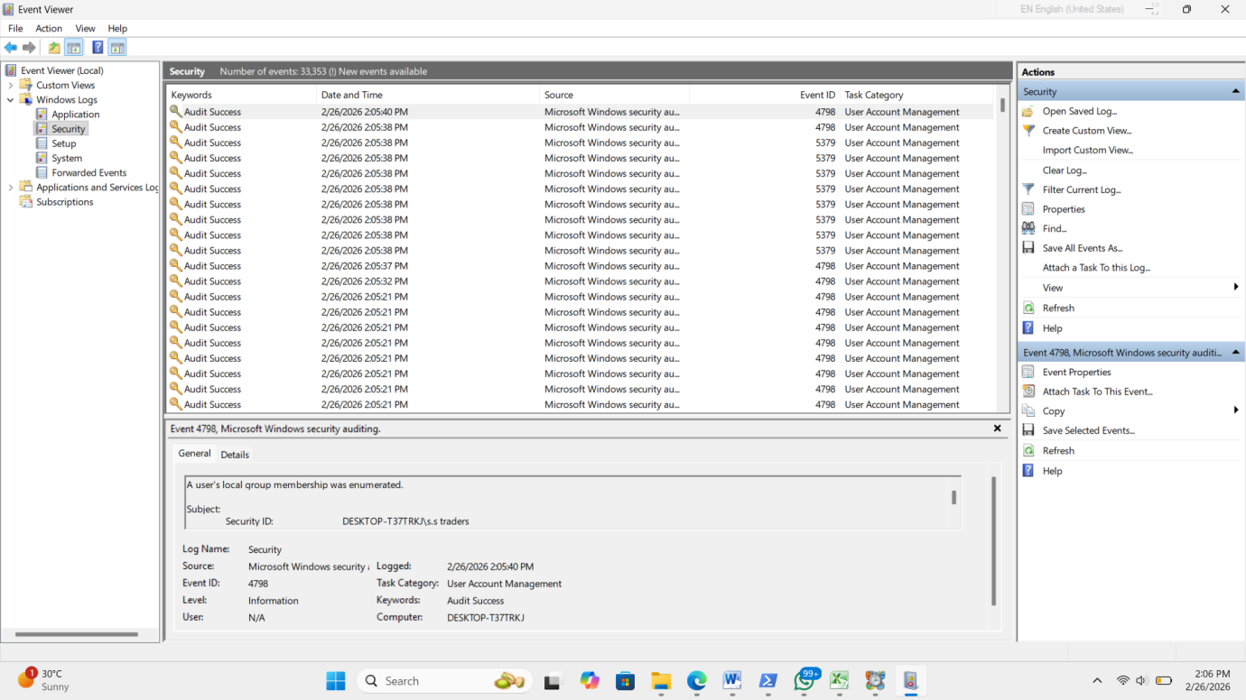Fig 1- Windows Security log entries showing recorded system and authentication events.
Description : The Security log contains authentication and system security events. Each entry is assigned a unique Event ID. These logs are used by SOC analysts to detect suspicious login activity and potential brute-force attempts.
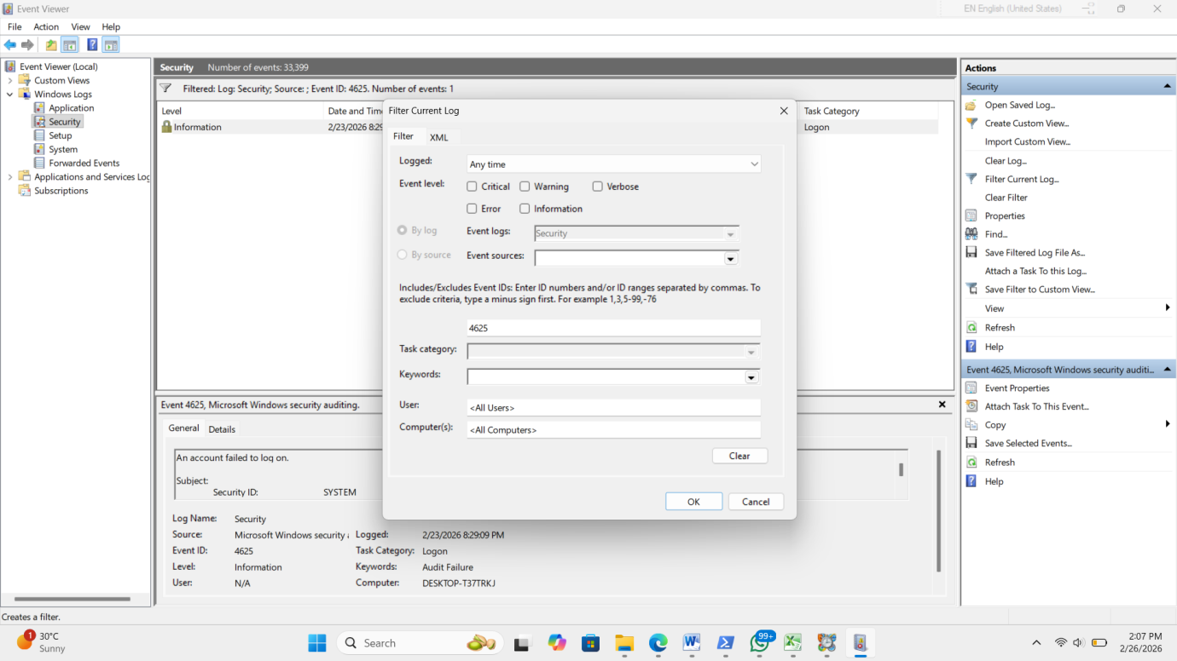
Figure 2: Filtering Security logs for Event ID 4625 (Failed Login Attempts).
Description: The “Filter Current Log” feature was used to isolate failed login attempts by entering Event ID 4625. This helps in identifying authentication failures and potential brute-force attack behavior.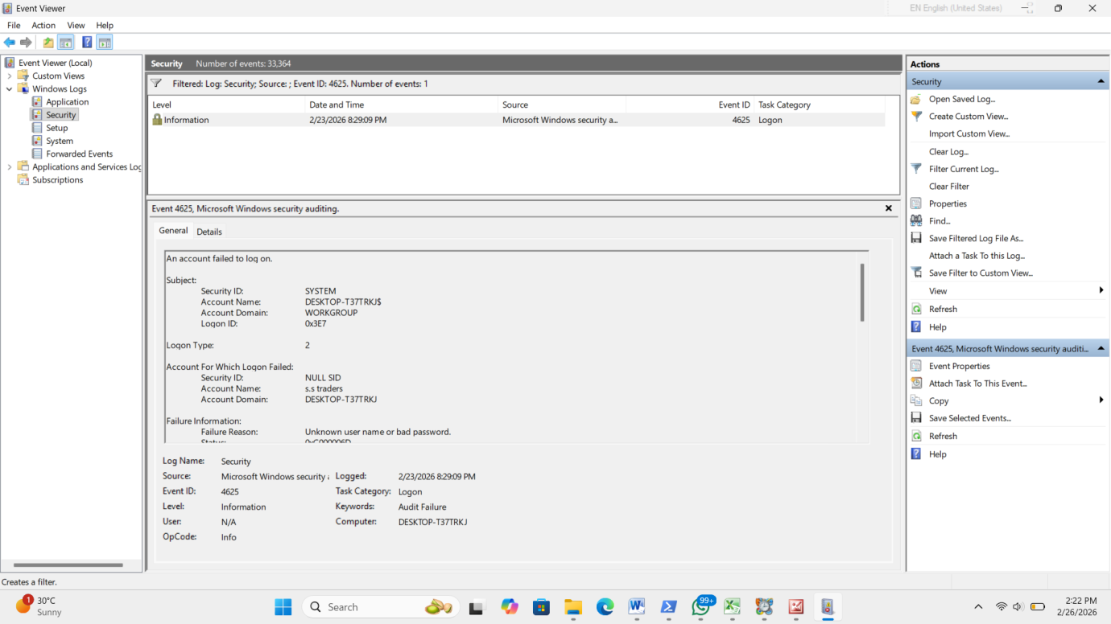
Figure 3:Filtered Security logs displaying failed login events (Event ID 4625).
Description: After applying the filter, only failed login events were displayed. The event details section provides information such as account name, logon type, failure reason, and source address, which are critical for security investigations.
-To identify Brute-force attacks from security logs-
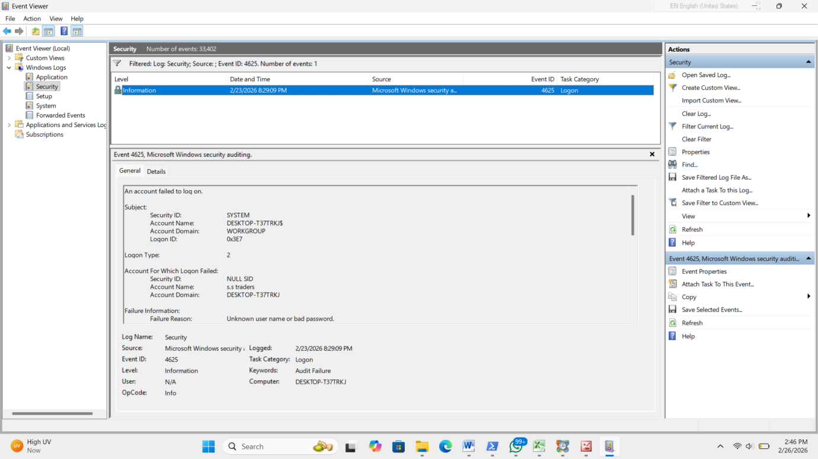
Figure 4 : Event ID 4625 showing failed login attempt detected in Windows Security Log.
The above screenshot shows a failed login attempt recorded under Event ID 4625 in the Windows Security log. The message “An account failed to log on” confirms that an authentication attempt was unsuccessful. The event details provide important information such as account name, logon type, failure reason, and source details.

Multiple failed login attempts were intentionally generated to simulate brute-force behavior. These events were successfully detected in Event Viewer, demonstrating how repeated authentication failures can be identified through security log monitoring.

- Browser history analysis –
The objective of this activity was to analyze Chrome browser history to identify visited websites and extract browsing artifacts using a forensic tool.

Tool Used- NirSoft Browsing HistoryView,Google Chrome

Procedure-
1. A test website (http://test.com) was visited to generate browsing activity.
2. Browsing History View was opened to analyze Chrome history.
3. The tool loaded browser history from the current user profile.
4. The search function was used to locate the test URL.
5. Results were exported to CSV format for further review.
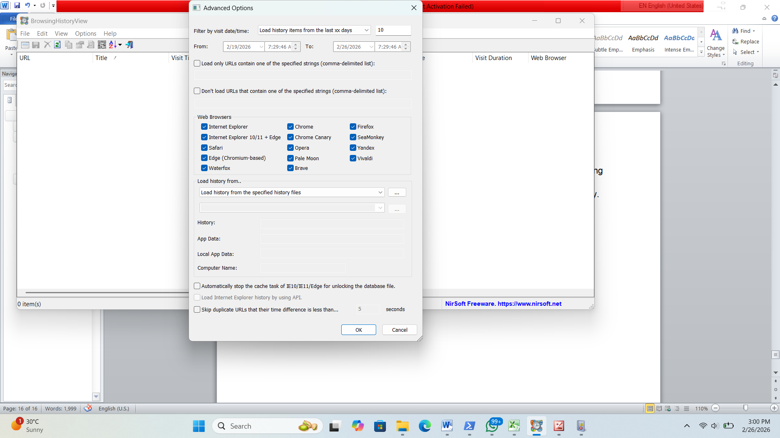
Fig 5 – exported browser history data reviewed in CSV format

- Document Security Events

Date/Time | Source IP | Event ID | Description | Action taken
23-02-2026 20:52 | 192.168.1.10 | 4625 | Multiple failed login attempts detected indicating possible brute-force attack | User account monitored and password reset recommended

The failed login event (Event ID 4625) was documented using a structured security event format. This approach helps SOC analysts systematically record security incidents including source details and response actions.

Documenting security events in a standardized format ensures clear incident
tracking, accountability, and efficient response in a real-world
SOC environment.

- Set up monitoring dashboards –
- In kibana - To create visual dashboards in Kibana to monitor security events and detect suspicious activity.
Step 1: Open Kibana Dashboard
• Navigate to Analytics → Dashboard, Click Create Dashboard,Click Create Visualization (Lens)
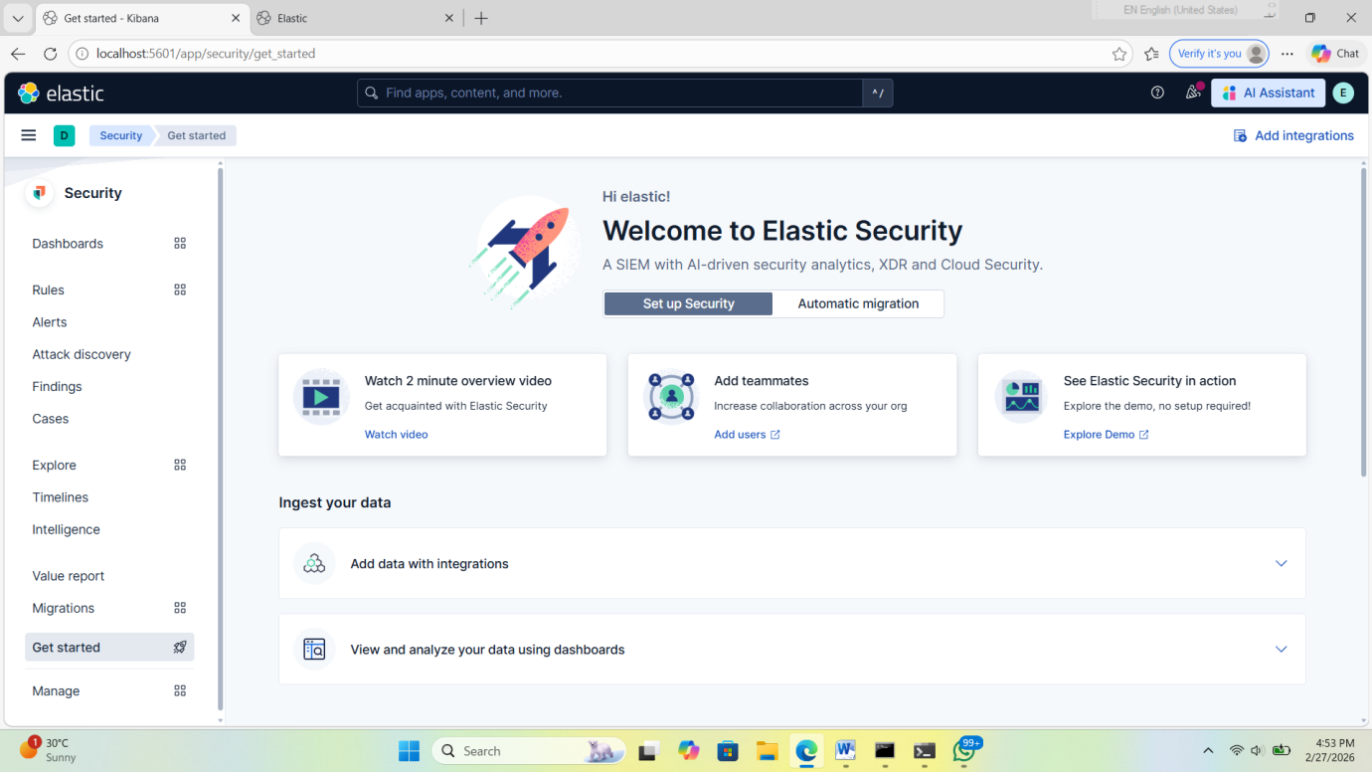
Figure6 – kibana dashboard

Step 2: Top 10 Source IPs Generating Alerts, Select data view: logs-* or security-, Drag source.ip to horizontal axis,Set aggregation to Top Values, Set count to 10, Keep vertical axis as Count ,Save as: Top 10 Source IPs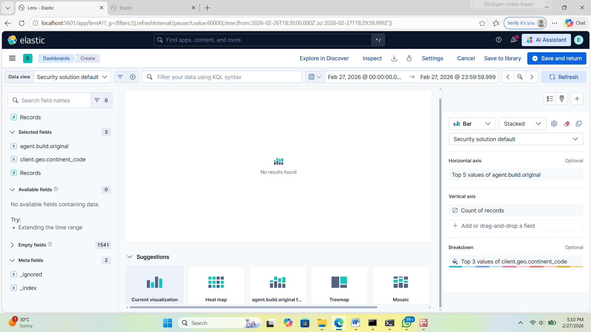
Figue7 – lens visualization showing top 10 source ips
Step 3: Frequency of Critical Event IDs - Create new visualization., Drag event.code to horizontal axis, Set aggregation to Top Values

-Currently, no live logs were ingested. However, the dashboard structure and visualizations were successfully configured and validated.

- Configure alert rules-
Alert Rule Configuration in Elastic SIEM
In this phase, an alert rule was created in Elastic SIEM to detect brute-force login attempts. Rule Configuration Details:
• Rule Name: Detect 5+ Failed Logins in 5 Minutes
• Index Pattern: security-login-*
• Condition: Trigger alert when failed login count > 5
• Time Window: 5 minutes
• Severity: High
• Risk Level: Medium to High
This rule is designed to detect potential brute-force attacks where an attacker attempts multiple login attempts within a short time frame. The detection logic monitors authentication failure events and counts the number of failed login attempts within a defined time window. If the threshold exceeds five attempts in five minutes, the system generates an alert.

Testing with Simulated Failed SSH Logins

To validate the alert rule, simulated failed SSH login attempts were performed.
The following command was used from another machine:
Ssh user@192.168.1.X
An incorrect password was entered multiple times intentionally to generate authentication failure logs. After exceeding five failed login attempts within five minutes:
• The logs were ingested into Elastic SIEM.
• The rule was triggered automatically.
• An alert was generated in the Security dashboard. Screenshots were captured showing:
• Failed authentication logs.
• Triggered alert in the SIEM dashboard.
• Alert details including source IP, timestamp, and event count.

This confirmed that the rule was functioning correctly.

